**DMS Question Bank**

**Theory**

**Unit 1 and 2**

1. Define indexed set. Given S = {a1, a2…a8} , what subsets are represented by **B19** and **B29?** How will you designate subsets **{a6, a7}** and **{a3}**

2) Define the following

a) Power Set

b) Cartesian Product

c) Partial ordering relation

d) Different operation on sets – Union, Intersection, Absolute complement, Relative Complement, Symmetric difference

3) Obtain the **PDNF** and **PCNF** of

a) ( 

4) Obtain the Prefix & Suffix form of following formulas respectively (2)

a) 

5) Demonstrate that R is a valid inference from the premises (2)

,  and 

6) Define indexed set. Given S = {a1, a2…a8} , what subsets are represented by **B31** and **B20?** How will you designate subsets **{a3, a6}** and **{a4}**

1. Show that for any two sets A and B
2. A - (A ∩ B) = A – B
3. A ∩ B = B ∩ A
4. A B ~ B ~A
5. Given A = { 2, 3, 4}, B = {1, 2} and C = {4, 5, 6}
6. A U B UC, A∩B, B ∩ C, A- B, A- C, B- A, C – A
7. find A + B, B + C, A + B + C, (A + B) + ( B + C )
8. Write A X B X C , A3, B2 where A = {1 } , B = { a, b} and C= {2,3}
9. If A1 = {{1.2}, {3}}, A2 = {{1}, {2, 3}}, A3 = {{1, 2, 3}} show that A1, A2 and A3 are mutually disjoint. Also find and ∩ Ai.
10. Draw Venn diagrams showing
11. A U B A U C but B C
12. A ∩ B A ∩ C but B C
13. A U B A U C but B C
14. A ∩ B A ∩ C but B C
15. Obtain equivalences of formulas-(formulas will be given)
16. Show that following formulas are tautology-(formulas will be given)
17. Show the following implications-(formulas will be given)
18. Show the conclusion is valid using truth tables--(formulas will be given)
19. Show by using rules of inference-(formulas will be given)

18. Draw Venn diagram showing  but  (2)

14 Given the relation matrix MR of a relation R on a set {a, b, c) , find the relation matrices of R, R2, RoR (6)

MR = 1 0 1

1 1 0

1 1 1

19. Define the following with examples (4)

a) Well formed formula

b) Substitution Instance

c) Tautology

d) Contradiction

e) Tautological implications

f) Functionally complete set of connectives

g) Duality law

h) PCNF

i) PDNF

20. Obtain the PDNF and PCNF of (4)

a) P V (┐P → (Q V (┐Q→ R)))

21. Obtain the Prefix & Infix form of following formulas respectively (4)

a)Q ┐(R <═> P V Q)

b) 

1. Explain Relation matrix. Let X = {1, 2, 3, 4} and R = {<x, y>|x<y}. Draw the graph

of relation R and give its matrix. (6)

23. Define the following with examples (4)

a) Equivalence relation

b) Power Set

24. Obtain the PDNF and PCNF of (4)

a) ( ↔ 

25. Obtain the Prefix & Infix form of following formulas respectively (4)

a) 

b) P ┐P → P → P →

26. Show that ┐Q, P→Q ═> ┐P

27. a) Define the Lattice as a POSET. Define GLB and LUB with examples (6)

b) Explain the tree traversal techniques (4)

28. Draw the Hasse diagram of the set {1, 2, 3, 6, 12}. Under the partial ordering (5)

relation “divides” and indicate whether it is total ordered or not

29. Describe the properties of binary relation.

30. Explain Composition of Functions with example

31. What is function? Give different types of functions with examples. (5)

32. Given a set X = { 1, 2, 3} and a relation R in X, R = {<1,2> , <2,1>, <3,3> } (5)

Find R2, R3, R4 and hence find transitive closure of R.

33. Obtain the PDNF and PCNF of (4)

a) ( ↔ 

34. Obtain the Prefix & Infix form of following formulas respectively (4)

a) 

b) 

1. Given a set X = { 1, 2, 3} and a relation R in X, R = {<1,2> , <2,1>, <3,3> } (5)

Find R2, R3, R4 and hence find transitive closure of R.

1. Define Function. Give types of functions and their examples
2. Let R = {<1,2>,<3,4>, <2,2>} , S = {<4,2>, <2,5>, <3,1>, <1,3>}

Find RoS, SoR, (RoS)oR, R3

1. Define relation matrix. Let X = {1, 2, 3, 4,5} and R = {<x, y>|(x-y) is integral multiple of 2}. Draw the graph of relation R and give its matrix.
2. Given relation matrices MR and MS. Find MRoS, MR, MS, MRoS

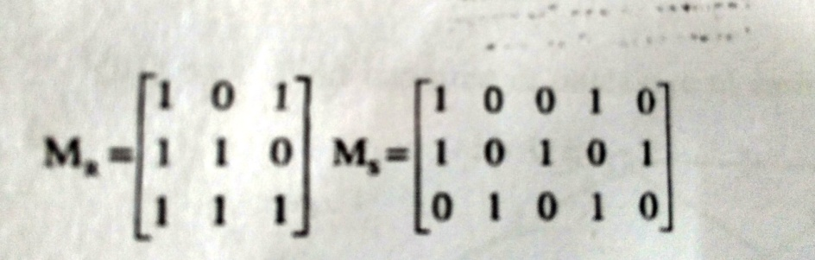

1. Let A = {a, b, c} denote the subsets of A by B0 to B7 . If R is the relation of proper inclusion on the subsets B0 to B7 , then give matrix of relation.
2. Let F(x) = x+2, g(x) = x-2, h(x) = 3x for x e R where R is the set of real numbers. Find g o f, f o g, f o f, g o g, hof, f o h, f o h o g
3. Let f = {<1,2>,<3,4>, <2,2>} , g = {<4,2>, <2,5>, <3,1>, <1,3>}

Fing f o g, g o f, f o f, g o g

1. Draw a Hasse diagram for (A,) (divisibility relation), where (i) A = {1, 2, 3, 4, 5, 6, 7, 8}; (iii) A = {2, 3, 4, 5, 6, 30, 60}; (v) A = {1, 2, 4, 8, 16, 32, 64}; (ii) A = {1, 2, 3, 5, 11, 13}; (iv) A = {1, 2, 3, 6, 12, 24}; (vi) A = {2, 4, 6, 12, 24, 36}.
2. Consider the poset ({3, 5, 9, 15, 24, 45},), that is, the divisibility relation.

(i) Draw its Hasse diagram.

(ii) Find its maximal, minimal, greatest and least elements when they exist.

1. Draw Hasse diagram of <A, ≤ > A = {1,2,3,4,5}; R in A x A is x <= y.
2. Let A be the set of factors of positive int m and let ≤ be relation divides . Draw Hasse diagrams for a) m = 12 b) m = 45 c) m= 210
3. Let A be a finite set and P(a) ts power set. Draw Hasse diagrams of <P(A),>

For a) A= {a,b, c} b) {a,b,c,d}

1. Draw the Hasse diagram of the set {1, 2, 3, 6, 12} and {1, 2, 3, 4, 6, 8, 12} . Under the partial ordering relation “divides” and indicate whether it is total ordered or not
2. Find the least member (if any) , greatest member (if any) , maximal members, minimal members, GLB of {a,d} and LUB of {a,d } for the given hasse diagram.

e

d c

a b

1. Let X= {2,3,6,12,24,36} and the relation ≤ be such that x ≤ y if x divides y. Draw Hasse diagram of < X, ≤ >.

* What are the lower bounds and upper bound for {2,3}?
* What are the LUB and GLB for {12,6}?
* What is the LUB and GLB for {2, 3, 6}?

1. List all possible functions from X={a, b, c} to Y = { 0, 1} and indicate in each case whether the function is one-to-one, is onto and is one-to-one onto.
2. Let f:X-> Y , g:Y-> Z, h: Z-> W then show that ho(gof) = (hog)of
3. Let R be the set of real numbers and let f:R-> R by given by f = { < x, x+2> | x belongs to R} then show that inverse function ~f is not a function.
4. Let f and g be the functions from R to R then find f o g, gof where f(x) = x2-2 and g(x) = x+4. State whether these functions are injective, surjective and bijective.
5. Explain the representation of discrete structures?

**Unit 3 : Algebraic systems**

1. Explain Semigroups and Monoids with their properties and examples.
2. Define w. r. t. Algebra – i) Epimorphism ii) Monomorphism iii) Isomorphism iv) Endomorphism
3. Explain Algebraic systems with examples and its properties
4. Prove that <Z4, +4> is a group, where +4 is congruence modulo 4
5. Define Clock algebra
6. Show that <B,+> is homomorphic image of <Z4, +4>
7. Define Algebraic systems. Give properties of Algebraic systems.
8. Let I be the set of integers, prove that <I,+> is a group.
9. Let <S, *>, <T,#> and <V, +> be semigroups and g:S->T and h:T -> V be semigroup homomorphism. Then hog: S -> V is a semigroup homomorphism from <S, *> to <V, +>
10. Given the algebraic systems <N,+> and <Z4, +4> where N is the set of natural nos and + is addition operation on N. Show that there exists homomorphism from <N,+> to <Z4, +4>
11. Define w.r.t group
    1. Order b. Degree c. Abelian group c. Cyclic Group

**12.** Define Direct product of Algebraic systems, Subalgebra, Homomorphism, Direct product of Algebra

13. Define Semigroups, Subsemigroups, semigroup homomorphism, Direct product of Semigroups

14. Define Monoids, Submonoids, Monoid homomorphism, cyclic monoids, Direct product of Monoids

15. Define with example – Groups, Subgroups, Group homomorphism, Direct product of groups, Abelian group, Cyclic groups, Symmetric groups(permution groups), Order of group

**Unit no. 4 Lattices**

1. Define the Lattice as a POSET. Define GLB and LUB with examples
2. Explain lattices as Algebraic systems
3. Define Boolean algebra and State its properties
4. List and define with examples different type of lattices
5. Show that the lattices given are not distributive

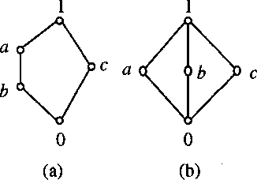

1. Determine whether the poset represented by each of Hasse diagram are lattices with reason :

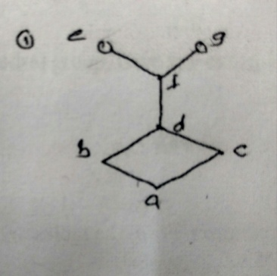

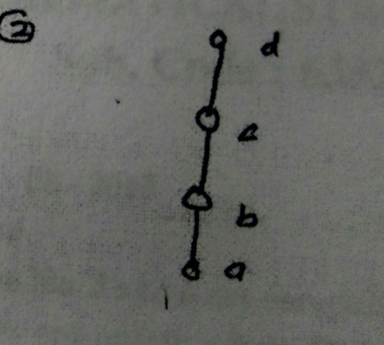

1. Let <l, *, +> be a lattice under divides relation show that L is a distributive lattice where L ={1,2,3,6,12}
2. Draw Hasse diagrams of lattices of order 5, <l2, <= >, <l3, <= >

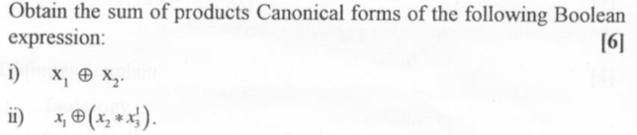

1. Q.2 Obtain SOP and POS form of above expressions -
2. 1. x1 * x2
3. 2. (x1+x2)’*(x1’*x3)
4. Q.3 find value of Boolean expressions x1 * x2 *[(x1 * x4) +x2’ +(x3*x1’)
5. Q.4 obtain values of the Boolean forms x1*(x1’+x2), x1*x2 and x1+(x1*x2) over the ordered pairs of the two element Boolean algebra
6. Q.5 obtain SOP form of
7. 1. (x+y)*(x’*y)
8. 2. (x*y)+(x’*y)+(y*z)
9. Q.6 Give a) truth table b) n-space representation c) Cube notation d) K-Map of ~ab+a~bc
10. Q.7 Give K-Map representation and minimization using K-Map

a) f(a, b, c) = ∑(0, 1, 4, 6)

b) ) f(a, b, c, d) = ∑(0, 5,7,8,12,14)

c) f(a, b, c, d) = ∑(0,1,2,3,13,15)

d) f(a, b, c, d,e) = ∑(9,20,21,29,30,31)

1. Q.8 Minimization using Cube notation/cube array representation

1. ∑ (0, 5, 7, 8, 12, 14)

2. ∑ (0, 1, 4, 5, 9, 11)

1. Q.9 Give a) truth table b) circuit diagram c) Cube notation d) K-Map of

1**. ~x ~y z+~x y ~z+x y ~z**

**2. ~w + y (~x+~z)**

**Unit 5 : Pemutations & Combinations, Probability theory**

1. Eplain Bayes theorem with example.
2. Explain the Rule of Sum and Product with example
3. In how many ways we can choose 3 out of 7 days if repetition is allowed
4. In how many ways three examinations be scheduled within five days period. If,
5. No two examinations are scheduled on same day
6. No restrictions on number of examinations schedules each day
7. In how many ways a team of 3 peaople will be selected from a group of 10?
8. When a certain defective die is rolled , the number from 1 to 6 will appear with the following probabilities

P (1) = 2/18, P(2) =3/18, P(3) =4/18, P(4) = 3/18, P(5) =4/18, P(6) = 2/18

Find the probability that

1. Odd number is on top
2. Prime number is on top
3. A number less than 5 is on top
4. There were three candidates for position of chairman of college Mr.X, Mr.Y and Mr.Z whose chances of getting the appointment are in the ration 4:2:3 respectively. The probability that Mr.X if selected would introduce computer education in the college is 0.3. The probabilities of Mr. Y and Mr.Z doing the same are respectively 0.5 and 0.8. What is the probability that there was computer education in the college?

**Unit no. 6 Graph theory**

1. Define Adjacency Matrix with example
2. Define with example Path matrix
3. Show that sum of in degree of all nodes of the following graph is equal to the sum of out degree of all its nodes and that this sum is equal to the number of edges of the graph?

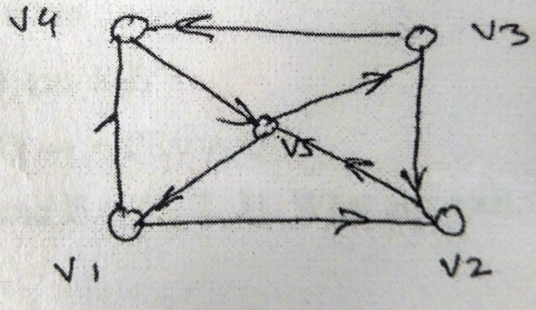

1. Find the adjacency matrix and path matrix of given graph. Also find AT , A2 and A.AT in above graph

e

d c

a b

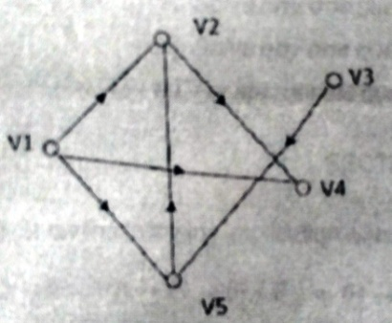

1. Find indegree and outdegree of each vertex of the following graph

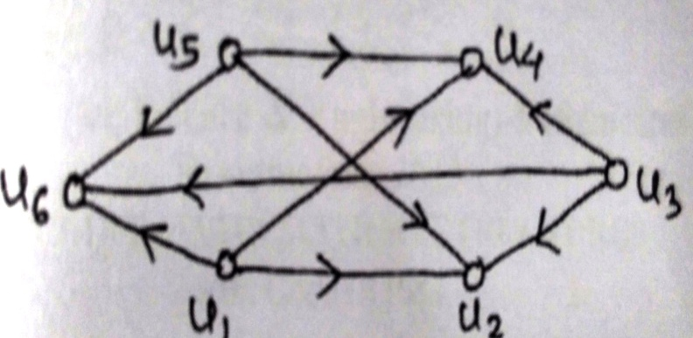

1. Find the degree of each vertex of the following graph

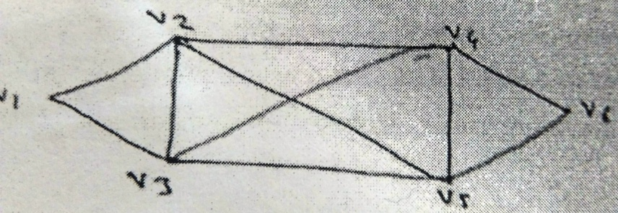

1. Check whether the following graphs are isomorphic or not?

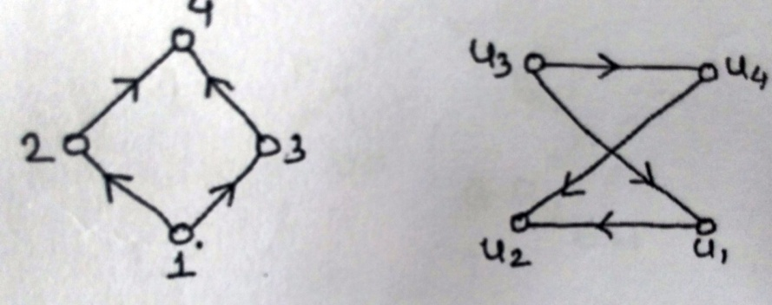

1. Find the reachabilty sets of all nodes and find the node base for the digraph

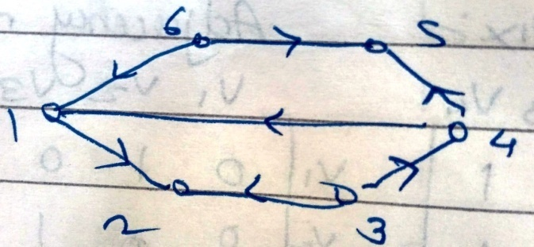

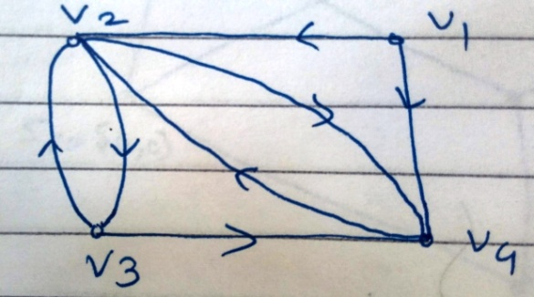

1. Find strong components, unilateral component and weak components of the given graph. Also find simple, elementary paths and simple, elementary cycles in the given graph . Consider the path originating in node1 and ending in node 3.

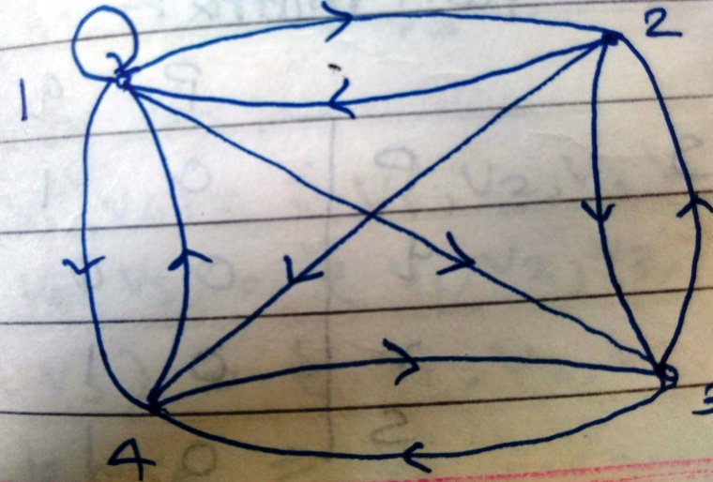



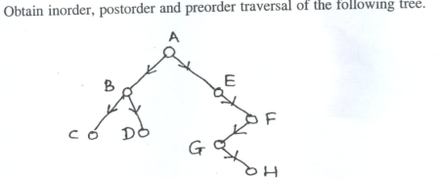

1. Define Euler Path and Euler Circuit with example
2. Define Hamilton Path and Hamilton circuit with example
3. Explain algorithm for constructing Euler circuits
4. Show that neither graph displayed in Figure given below has a Hamilton circuit.



1. Determine whether the directed graph shown has an Euler circuit. Construct an Euler circuit if one exists. If no Euler circuit exists, determine whether the directed graph has an Euler path. Construct an Euler path if one exists.



1. Is *K*3*,*3, shown in Figure , planar?



1. Show that *K*5 is nonplanar using Corollary 1 *e* ≤ 3*v* − 6.
2. Find Tree traversal –Preorder, Inorder, Postorder of Given tree-



**Objective**

1) Which of the following is WFF? (1)

a)  b) ) c)  d)

2) State which is the minimal functionally complete set (1)

a){ ↑} b) ,  c) {↓, V} d) 

3) State which are the maxterms. (1)

a) PQ b) P V┐Q c) P d) P V Q

4State which of the following proposition is a tautology? (2)

a) (P V Q) →Q b) P V (Q→P) c) PV (P→Q) d) P→ (P→Q)

5) Let R:X to Y, S:Y to Z and P:Y to Z be the relations then Composition of relation RoS is not a) Symmetric b) Associative c) Both symmetric and associative d) None (1)

6) Dual of A V T is

a) A F b) A c) A V F d) T V F (1)

7) A statement formula P→(Q→R) is equivalent to (1)

a) (P → R b) (P→Q)→R c) P→ (QVR) d) (PQ) V R

8) If S = (a1, a2,. . . ., a8) then how is the subset { a2, a6, a8} designated? (2)

1) Which of the following is WFF? (1)

a)  b)  c)  d)

2) State which is the functionally complete set (1)

a) b)  c)  d) 

3) State which of the following is the minterm. (1)

a) PQ b) PQ c) P d) P P

4) State whether ((**P Q)  ¬ (¬ P(¬Q¬R))) (¬P¬Q)(¬P¬R)** is (2)

a) Tautology b) Contradiction c) None

5) Cartesian Product of 2 sets A and B is (1)

a) Commutative b) Associative c) Idempotent d) None

6) If A and B are two sets then A∩ (A U B) equals (1)

a) A b) B c) Ø d) None

7) Given A1 = {2, 5, 6}, A2 = {3, 4, 2} A3 = {1, 2, 3}, what is? (1)

a) {1,2,3,4,5,6} b) {3,4} c){2} d) {3,4,5,6}

8) Given A = {2, 5, 6}, B = {3, 4, 2} A+ B=?

a) {5, 6} b) {3, 4} c) {2} d) {3, 4, 5, 6} (1)

9) is equivalent to (1)

a) P V Q b)  c) d) 

10) Find R when A = {1, 2, 3, 4, 5} and R is defined on A by xRy iff x+2 = y (1)

a) {<1,3>, <2,4>} b) {<1,3>,<2,5>} c) {<1,4>,<2,5>} d) {<1,4>,<4,5>}

11) If S = (a1, a2,. . . ., a8) then how is the subset { a1, a5, a7} designated? (2)

12) There exists a Partial ordering relation <= on B. If a<=b then a **⊕** b = ……..

**a) 1 b) a c) b d) 0**

13) The Hasse diagram of totally ordered set is represented as a ________

**a) Single line b) diamond c) chain d) cube**

14) In a Lattice <l, ≤> for any a, b, c if b≤c then which of following is true

**a) c ≤ b b) a*b ≤ b*c c) a*b ≤ a*c d) a+b ≤ b+c**

15) A lattice is called Boolean algebra if it is

**a) Complemented & distributive b) Complemented only**

**c) Distributive only d) Complemented or distributive**

16) Which of the following is not true in case of Boolean algebra: a+b: LUB of a & b

a*b: GLB of a & b.

1. **(a*b)’ = a’ +b’ b)a*(a+b) = b c) a*a’ = 0 d)a+a’ = 1**

17) Which of the following is an application of graph theory?

a**) Fault detection in combinational circuits b) PERT c) finding shortest path in network d) all of above**

18) I) every element of lattice has at least one complement II) a lattice satisfies property of absorption.

Which of the following are true?

**a) I & II b) I only c) II only d) none**

19) A vertex of degree 0 is called a ___________ node

**a) Isolated b) pendant c) simple d) terminal**

20) The SOP form of x1*x2 in 3 variables x1, x2 and x3 is (2 marks)

**a)*(6,7) b) +(0,1) c) *(0,1) d) +(6,7)**

21) There exists a Partial ordering relation <= on B. If a<=b then a **⊕** b = ……..

a) 1 b) a c) b d) 0

22) The Hasse diagram of Totally ordered set is represented as a ________

a) Single line b) diamond c) chain d) cube

23) If A and B are two sets then A∩ (A U B) equals

a) A b) B c) Ø d) None

24) In a Lattice <l, ≤> for any a, b, c if b≤c then which of following is true

a) c ≤ b b) a*b ≤ b*c c) a*b ≤ a*c d) a+b ≤ b+c

25) Let R be a symmetric and transitive relation on a set A then

a) R is reflexive & hence a equivalence relation

b) R is reflexive and hence partial order

c) R is not reflexive & hence not an equivalence relation

d) None of these

26) A lattice is called Boolean algebra if it is

a) Complemented & distributive b) Complemented only

c) Distributive only d) Complemented or distributive

27) Let f: R →R be defined by f(x) = 3x-7. Then inverse function f inverse R →R is

a) (x+3)/7 b) (x-7)/3 c) (x+7)/3 d) x/3

28) Which of the following is not true in case of Boolean Algebra: a+b: LUB of a & b

a*b: GLB of a & b.

1. (a*b)’ = a’ +b’ b)a*(a+b) = b c) a*a’ = 0 d)a+a’ = 1

29) The relation R defined on the set A={1, 2, 3, 4} by R = {<1,1>, <2, 2>, <3,3>} is

a) Reflexive b) Symmetric & irreflexive c) transitive & reflexive d) None

30) Find R when A = {1, 2, 3, 4, 5} and R is defined on A by xRy iff x+2 = y

a) {<1,3>, <2,4>} b) {<1,3>,<2,5>} c) {<1,4>,<2,5>} d) {<1,4>,<4,5>}

1. Sets A and B have 3 and 6 elements each. What can be the minimum number of elements in

A U B?

1. 3 b) 6 c) 9 d) 18
2. Find R3 when A = {1,2,3,4,5} and R is defined on A by xRy iff x+1 = y
3. {<1,3>,<2,4>} b) {<1,3>, <2,5>} c) {<1,4>,<2,5>} d) {<1,4>,<4,5>}
4. The function R->R given by f(x) = x2 is
5. One-one b)onto c) one-one onto d) none of these
6. A diagraph is called __________ connected if it is connected as an undirected graph in which directed edge is converted to an undirected graph
7. Strongly b) weakly c) unilaterally d) none of these
8. Process first the root node, then left subtree followed by right subtree is ________technique.
9. Preorder b) postorder c) inorder d) None
10. A graph containing both directed and undirected edges is called as
11. Directed graph b)Digraph c)Undirected graph d)Mixed graph
12. A set of disjoint trees is called as
13. Forest b) graph c) isolated graph d) maximal graph
14. A directed graph is associated with
15. Ordered pair of vertices b)adjacent vertices c) unordered pair of vertices d)none
16. A vertex of degree 0 is called as _________ node
17. Isolated b)pendant c) simple d) terminal
18. Set A has n elements. The number of functions that can be defined from A into A is
19. n2  b) n! c) nn  d) n